 |  |     Follow Us on Facebook and Instagram!
  MAKING A DIFFERENCE where IT COUNTS
  Responsible Pet Ownership Education
  Animal Wellness Education
  Quality Pet Owner Resources
  Our society has been established and continues to work in collaboration and cooperation with the Town of Coaldale and Municipal Enforcement
  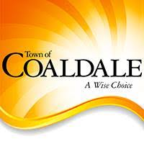
  “Dogs have a way of finding the people who need them, and filling the emptiness we didn’t ever know we had.”
  Thom Jones
  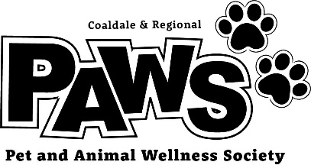
   | “Saving one dog will not change the world, but surely for that one dog, the world will change forever.”  Karen Davison  For questions and volunteer information, email us at  coaldaleregionalpaws@gmail.com
  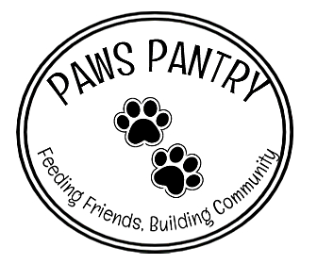
  Coaldale’s First Dog-Specific Food Bank Resource for Pet Parents

 |  | 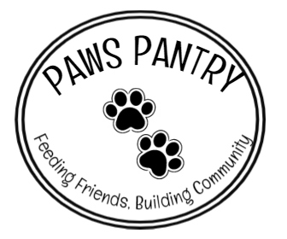 |  | DONATE TODAY!  We are currently accepting unopened, unexpired bags and cans of dog food. From generic to specialty foods, any donation is welcome!  You can donate at any time! We have donation bins set up at the following locations:  The Coaldale Pet Clinic  The Coaldale Firehall  The Pet Corner  KNOW A PET IN NEED?  WHEN & WHERE? The PAWS Pantry is open for pet parents to use every second Saturday of each month, from 1-4pm at the Coaldale Firehall (1507 20th Ave).  WHO CAN UTILIZE THE PANTRY? The PAWS Pantry is exclusively available to residents of Coaldale and surrounding areas, excluding Lethbridge. Community Animal Services (CAS) in Lethbridge hosts their own pet food bank, which is available to Lethbridge residents only.  WHAT DO YOU NEED? Similar to the human food bank and CAS food bank, patrons of the PAWS Pantry are required to show identification (something that provides an address) before collecting food. Limited to one bag or flat of food per household.  STAY UPDATED! The PAWS Pantry hours of operation, frequency and distribution amounts may change based on donations and demand. Ensure to follow us on social media for updates!
  
  Who are we and what are we doing?
  We saw A need in our community…
  The resources that were available to house dogs until they could be reunited with their owners or adopted out, are no longer available to the displaced dogs within Coaldale or surrounding regions.
  That loss of resources, plus the unprecedented increase of dog-related calls since 2022, has created a significant deficit in animal care and the need for more animal resources in our area. Concerned citizens created the society and have collaborated with the Town of Coaldale to help fill that need!
  We want to be the first call dog owners make to gain knowledge and support for their furry friends, with offering as many resources as we can with the hopes to significantly reduce or eliminate completely the number of surrendered/stray/abandoned animals in our community as well as animal-related incidents.
  Picture it… a resource hub for displaced dogs and pet owners, right in your own community!
  Our goal is to have a multifunctional facility within Coaldale that is available for pet owners and other animal support resources to utilize either to contribute to community pet wellness, or to take advantage of the available resources.
  - Safe and nurturing kennel facility for displaced dogs.
  - Conference room for pet owner information sharing sessions.
  - Database for resources such as specialty trainers and veterinarians.
  PAWS PANTRY
  The PAWS Pantry is our inaugural pet parent resource!
  Introducing the PAWS Pantry, our first dedicated resource for pet parents! We’ve established a dog-food bank to support pet owners within Coaldale and surrounding areas during tough times.
  By providing this crucial resource, we aim to prevent surrenders and abandonments due to financial strain.
  This resource is strictly donation based, so the more donations we have, the more there is available to pet parents in need.
  The success of the PAWS Pantry relies heavily on community support and donations. Your generosity ensures that no pet goes hungry, reinforcing the compassionate spirit that defines our community.

